BANK LOAN REPORT

PROBLEM STATEMENT
In order to monitor and assess our bank's lending activities and performance, we need to create a comprehensive Bank Loan Report. This report aims to provide insights into key loan-related metrics and their changes over time. The report will help us make data-driven decisions, track our loan portfolio's health, and identify trends that can inform our lending strategies.
Key Performance Indicators (KPIs) Requirements:
- Total Loan Applications
- Total Funded Amount
- Total Amount Received
- Average Interest Rate
- Average Debt-to-Income Ratio (DTI)
Good Loan v Bad Loan KPI’s
In order to evaluate the performance of our lending activities and assess the quality of our loan portfolio, we need to create a comprehensive report that distinguishes between 'Good Loans' and 'Bad Loans' based on specific loan status criteria
Good Loan KPIs:
- Good Loan Application Percentage
- Good Loan Applications
- Good Loan Funded Amount
- Good Loan Total Received Amount
Bad Loan KPIs:
- Bad Loan Application Percentage
- Bad Loan Applications
- Bad Loan Funded Amount
- Bad Loan Total Received Amount
Loan Status Grid View
In order to gain a comprehensive overview of our lending operations and monitor the performance of loans, we aim to create a grid view report categorized by 'Loan Status.' This report will serve as a valuable tool for analysing and understanding the key indicators associated with different loan statuses. By providing insights into metrics such as 'Total Loan Applications,' 'Total Funded Amount,' 'Total Amount Received,' 'Month-to-Date (MTD) Funded Amount,' 'MTD Amount Received,' 'Average Interest Rate,' and 'Average Debt-to-Income Ratio (DTI),' this grid view will empower us to make data-driven decisions and assess the health of our loan portfolio.

Report Requirements :
In our Bank Loan Report project, we aim to visually represent critical loan-related metrics and trends using a variety of chart types. These charts will provide a clear and insightful view of our lending operations, facilitating data-driven decision-making and enabling us to gain valuable insights into various loan parameters. Below are the specific chart requirements:
1. Monthly Trends by Issue Date
2. Regional Analysis by State
3. Loan Term Analysis
4. Employee Length Analysis
5. Loan Purpose Breakdown
6. Home Ownership Analysis

BANK LOAN REPORT QUERY DOCUMENT
KPI’S :
Total Loan Applications :
SELECT
COUNT(id) AS total_loan_applications
FROM
bank_loan_data
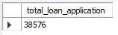

MTD Loan Application :
SELECT
COUNT(id) AS MTD_total_loan_applications
FROM
bank_loan_data
WHERE
MONTH(issue_date) = 12
AND YEAR(issue_date) = 2021
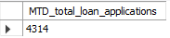

PMTD Loan Applications :
SELECT
COUNT(id) AS PMTD_total_loan_applications
FROM
bank_loan_data
WHERE
MONTH(issue_date) = 11
AND YEAR(issue_date) = 2021
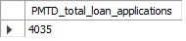

Total Funded Amount :
SELECT
SUM(loan_amount) AS total_funded_amount
FROM
bank_loan_data
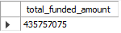

MTD Total Funded Amount :
SELECT
SUM(loan_amount) AS MTD_total_funded_amount
FROM
bank_loan_data
WHERE
MONTH(issue_date) = 12
AND YEAR(issue_date) = 2021
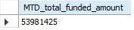

PMTD Total Funded Amount :
SELECT
SUM(loan_amount) AS PMTD_total_funded_amount
FROM
bank_loan_data
WHERE
MONTH(issue_date) = 11
AND YEAR(issue_date) = 2021
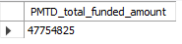

Total Amount Received :
SELECT
SUM(total_payment) AS total_amount_recived
FROM
bank_loan_data
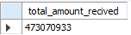

MTD Total Amount Received :
SELECT
SUM(total_payment) AS MTD_total_amount_recived
FROM
bank_loan_data
WHERE
MONTH(issue_date) = 12
AND YEAR(issue_date) = 2021
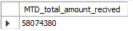

PMTD Total Amount Received :
SELECT
SUM(total_payment) AS PMTD_total_amount_recived
FROM
bank_loan_data
WHERE
MONTH(issue_date) = 11
AND YEAR(issue_date) = 2021
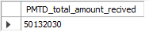

Average Interest Rate :
SELECT
ROUND(AVG(int_rate) * 100, 2) AS avg_interest_rate
FROM
bank_loan_data
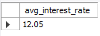

MTD Avg Interest Rate :
SELECT
ROUND(AVG(int_rate) * 100, 2) AS MTD_avg_interest_rate
FROM
bank_loan_data
WHERE
MONTH(issue_date) = 12
AND YEAR(issue_date) = 2021
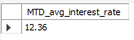

PMTD Avg Interest Rate :
SELECT
ROUND(AVG(int_rate) * 100, 2) AS PMTD_avg_interest_rate
FROM
bank_loan_data
WHERE
MONTH(issue_date) = 11
AND YEAR(issue_date) = 2021
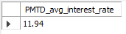

Avg Debt To Income Ratio :
SELECT
ROUND(AVG(dti) * 100, 2) AS avg_dti
FROM
bank_loan_data
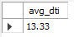

MTD Avg Debt To Income Ratio :
SELECT
ROUND(AVG(dti) * 100, 2) AS MTD_avg_dti
FROM
bank_loan_data
WHERE
MONTH(issue_date) = 12
AND YEAR(issue_date) = 2021
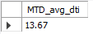

PMTD Avg Debt To Income Ratio :
SELECT
ROUND(AVG(dti) * 100, 2) AS PMTD_avg_dti
FROM
bank_loan_data
WHERE
MONTH(issue_date) = 11
AND YEAR(issue_date) = 2021
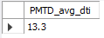

GOOD LOAN ISSUED
Good Loan Percentage :
SELECT
ROUND((COUNT(CASE
WHEN
loan_status = 'Fully Paid'
OR loan_status = 'Current'
THEN
id
END) * 100) / COUNT(id),
2) AS good_loan_percentage
FROM
bank_loan_data
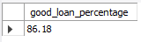

Good Loan Applications :
SELECT
COUNT(id) as good_loan_applications
FROM
bank_loan_data
WHERE
loan_status = 'Fully Paid'
OR loan_status = 'Current'
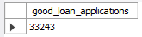

Good Loan Funded Amount :
SELECT
sum(loan_amount) as good_loan_funded_amount
FROM
bank_loan_data
WHERE
loan_status = 'Fully Paid'
OR loan_status = 'Current'
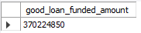

Good Loan Received Amount :
SELECT
sum(total_payment) as good_loan_received_amount
FROM
bank_loan_data
WHERE
loan_status = 'Fully Paid'
OR loan_status = 'Current'
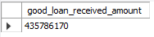

BAD LOAN ISSUED
Bad Loan Percentage :
SELECT
ROUND(COUNT(CASE
WHEN loan_status = 'Charged off' THEN id
END) * 100 / COUNT(id),
2) AS bad_loan_percentage
FROM
bank_loan_data
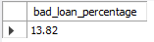

Bad Loan Applications :
SELECT
COUNT(id) AS bad_loan_applications
FROM
bank_loan_data
WHERE
loan_status = 'Charged off'
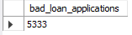

Bad Loan Funded Amount :
SELECT
sum(loan_amount) AS bad_loan_funded_amount
FROM
bank_loan_data
WHERE
loan_status = 'Charged off'
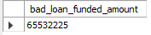

Bad Loan Received Amount :
SELECT
sum(total_payment) AS bad_loan_received_amount
FROM
bank_loan_data
WHERE
loan_status = 'Charged off'
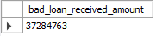

Loan Status :
SELECT
loan_status,
COUNT(id) AS total_loan_applications,
SUM(total_payment) AS total_amount_received,
SUM(loan_amount) AS total_funded_amount,
AVG(int_rate * 100) AS interest_rate,
AVG(dti * 100) AS dti
FROM
bank_loan_data
GROUP BY loan_status
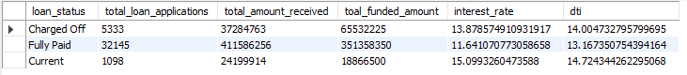

MTD Total Funded And MTD Total Received Amount Loan Status :
SELECT
loan_status,
SUM(total_payment) AS MTD_total_amount_received,
SUM(loan_amount) AS MTD_total_funded_amount
FROM
bank_loan_data
WHERE
MONTH(issue_date) = 12
GROUP BY loan_status
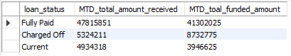

Report Requirements :
Monthly Trends By Issue Date :
SELECT
MONTH(issue_date) AS month_number,
DATE_FORMAT(issue_date, '%M') AS month_name,
COUNT(id) AS total_loan_applications,
SUM(total_payment) AS total_amount_received,
SUM(loan_amount) AS total_funded_amount
FROM
bank_loan_data
GROUP BY MONTH(issue_date) , DATE_FORMAT(issue_date, '%M')
ORDER BY MONTH(issue_date)
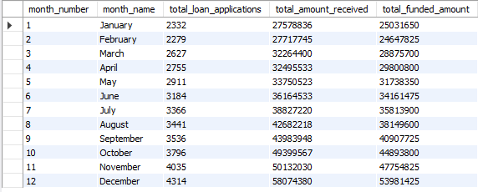

Regional Analysis By State :
SELECT
address_state AS state,
COUNT(id) AS total_loan_applications,
SUM(total_payment) AS total_amount_received,
SUM(loan_amount) AS total_funded_amount
FROM
bank_loan_data
GROUP BY address_state
ORDER BY address_state
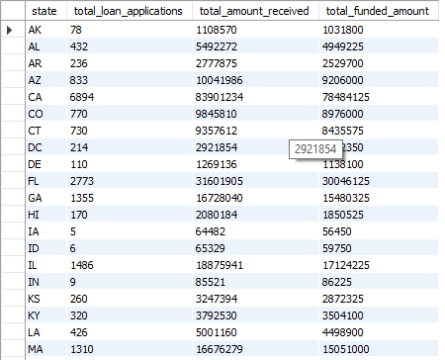

Loan Term Analysis :
SELECT
term,
COUNT(id) AS total_loan_applications,
SUM(total_payment) AS total_amount_received,
SUM(loan_amount) AS total_funded_amount
FROM
bank_loan_data
GROUP BY term
ORDER BY term
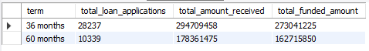

Employee Length Analysis :
SELECT
emp_length as employee_length,
COUNT(id) AS total_loan_applications,
SUM(total_payment) AS total_amount_received,
SUM(loan_amount) AS total_funded_amount
FROM
bank_loan_data
GROUP BY emp_length
ORDER BY emp_length
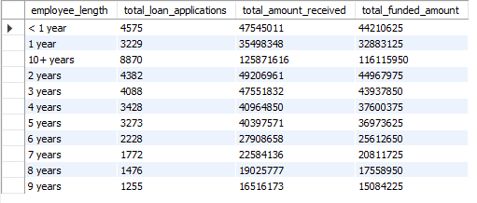

Loan Purpose Breakdown :
SELECT
purpose,
COUNT(id) AS total_loan_applications,
SUM(total_payment) AS total_amount_received,
SUM(loan_amount) AS total_funded_amount
FROM
bank_loan_data
GROUP BY purpose
ORDER BY COUNT(id) DESC
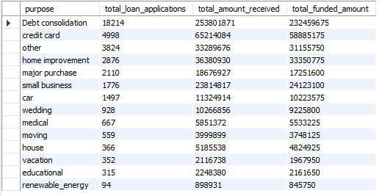

Home Ownership Analysis :
SELECT
home_ownership,
COUNT(id) AS total_loan_applications,
SUM(total_payment) AS total_amount_received,
SUM(loan_amount) AS total_funded_amount
FROM
bank_loan_data
GROUP BY home_ownership
ORDER BY COUNT(id) DESC
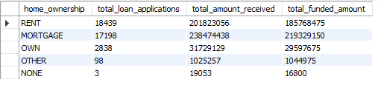

KEY FINDINGS AND INSIGHTS :
- The data demonstrates a very healthy and consistent growth pattern for the bank throughout the observed year, with a strong finish in the last quarter (October, November, December).

- The regional data highlights that the loan activity is highly concentrated in a few key states, primarily CA and FL, while many other states represent small or negligible parts of the overall portfolio. The bank's strategy appears to be heavily focused on these high-volume markets.

- The bank's loan portfolio is heavily lean towards the shorter, 36-month term in application count, but the longer, 60-month term loans carry a significantly higher average principal balance.

- The bank's portfolio is heavily reliant on two stable but distinct segments: the most established employees (10+ years), who are the bank's premium customers, and the newest employees (< 1 to 3 years), who represent a high-volume, potentially younger, segment with smaller average loan needs. The bank's risk model seems comfortable lending to both type of loan needs.
- Calculating the average funded amount (Total Funded Amount / Total Applications) provides insight into the typical size of loans for each purpose:
Debt Consolidation: $232.46M / $18214 = $12763
Small Business: $24.12M / $1776 = $13570 (Highest average size among top 3)
Credit Card: $58.89M / $4998 = $11783
- The Small Business purpose has the highest average loan size among the all categories, suggesting these borrowers require more significant capital than those consolidating debt or paying off credit cards.

- Calculating the average funded amount (Total Funded Amount / Total Loan Applications) provides insight into the typical size of loans for each purpose:
Average RENT Funded Amount : $185,768,475 / $18,439 = $10,075

Average MORTGAGE Funded Amount: $219,329,150 / $17,198 = $12,753(Highest average size among top 3)

Average OWN Funded Amount: $29,597,675 / $2,838 = $10,429

- Borrowers with a MORTGAGE receive, on average, a loan that is over $2,600 larger than RENT
and around $2250 larger than OWN FUNDED AMOUNT.
- The total amount received is consistently higher than the total funded amount for all categories, confirming that all segments are generating interest and positive cash flow for the bank.

